WRAG’s website address:
http://www.pesticides.gov.uk/guidance/industries/pesticides/advisory-groups/Resistance-Action-Groups/wrag

MINUTES OF WRAG STEERING GROUP MEETING

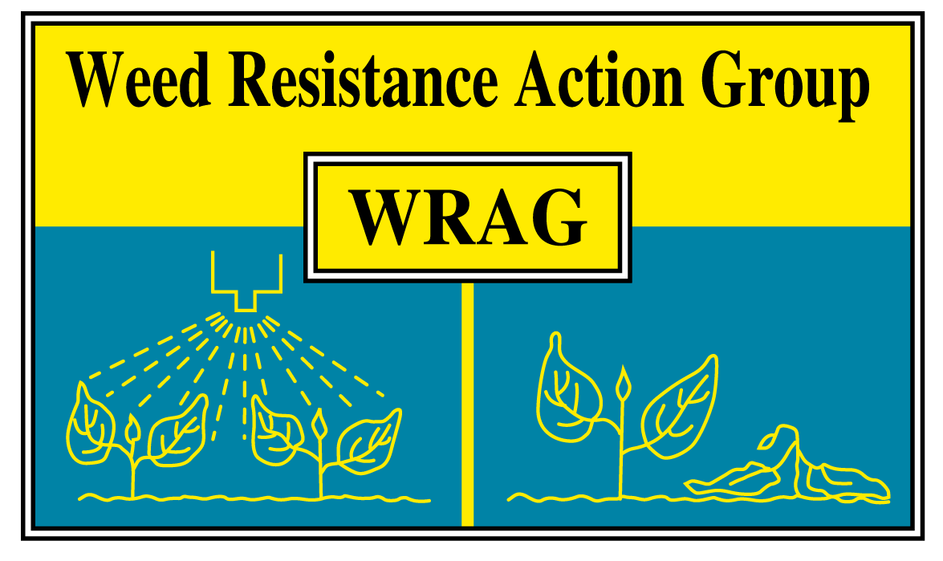

Friday 4 April 2014

ADAS Boxworth

Members present (10+4): James Clarke (Chairman), Stephen Moss (Secretary), Ingrid den Hoed (CRD), Mark Ballingall (SRUC), Paul Neve (University of Warwick), Gordon Anderson-Taylor (Bayer), Iain Ford (BASF), Eileen Patterson (Dow), Jason Tatnell (Syngenta), Steve Cranwell (DuPont). Plus Lynn Tatnell (ADAS), Richard Hull (Rothamsted), Manda Sansom (Monsanto), Dick Dyason (NuFarm) by invitation.

1. Apologies for absence. Clare Bend (Agrii), Anne Thompson (Eileen Patterson substituting).

2. The minutes of the last Steering Group meeting (27 November 2013) were approved. These can be viewed on the WRAG website.

3. WRAG’s contribution to the AAB Crop Production in Southern Britain Conference (25/26 November 2014).

This was discussed and it was agreed that having a session linked to WRAG would be appropriate, especially as WRAG will have been in existence for 25 years by September 2014. Subsequent discussions with the organiser (Jim Orson) has resulted in the following suggestion for a session given over to herbicide resistance
• Co-brand – supported by WRAG (at least for the session) and we will circulate conference details to WRAG emails lists.
• Suggested content (order and content to be agreed with AAB):
- WRAG – the next 25 years – Clarke and Moss (a forward looking paper, capturing lessons of first 25 years (e.g. agreement of strategies, communications, testing methodology, and demonstrating how will help in next 25 years (e.g. for BLW resistance – linking to Tatnell paper – and in regulation context – linking to den Hoed paper – and managing glyphosate risks).
- Compilation update of resistance incidence – Hull, Tatnell, Moss et al.
- Regulatory issues, using herbicides as examples – Ingrid den Hoed – this could fit here or could be just before this session
- Paper on black-grass resistance to pre-emergence herbicides Hull, Moss et al.
- Paper on poppy/BLW resistance – Tatnell et al.

4. The potential for resistance to glyphosate in the UK.

Stephen Moss presented a summary of work done at Rothamsted on the response of sterile brome populations to glyphosate. Two field populations, from Leicestershire and Oxfordshire, were identified which showed some insensitivity to glyphosate at field recommended rate of 540 g a.i./ha. Dose response experiments showed Resistance Indices of about two relative to susceptible standards. However, populations from areas never previously treated with glyphosate on the same farms showed no insensitivity, supporting the view that some selection had occurred in the field populations. Further studies showed small differences in response between commercial formulation and also loss of activity of about 15% when tap water with medium hardness was compared with deionised water. Rates lower than 540 g/ha resulted in poorer control of all populations studied, demonstrating that the recommended rate for annual grass weeds is somewhat marginal on sterile brome, especially if other factors reduce activity (e.g. environmental conditions, water hardness, marginal resistance).

Paul Neve presented a summary of research done by his PhD student (Laura Davies) on the potential for glyphosate resistance in black-grass in the UK. Laura had done dose response experiments on 40 populations and obtained field histories for most of these. There was some variation in response between populations, but rather less than might have been expected (ED₅₀ range 250 – 350 g a.i./ha). However, a known susceptible population (Rothamsted) was at the more sensitive end, while multiple herbicide-resistant Peldon was at the least sensitive end of the range. In addition, there was a positive correlation between past intensity of glyphosate use and sensitivity in the dose response assays. Subsequent selection studies on a range of populations did show progressive shifts in sensitivity, but the scale of these was quite small. There was no evidence that any of the black-grass populations currently show resistance to glyphosate but the potential for further selection was clearly demonstrated.

There followed a discussion about the risks of glyphosate resistance in the UK. There would appear to be an increased risk of resistance in reduced/no cultivation situations where kill of plants is totally dependent on the herbicide, with no additional control from cultivations. This factor is likely to also be relevant to the amenity and industrial weed control sector which was thought to present the biggest risk, especially as repeat applications of glyphosate may be used and a lack of alternative modes of action. In parts of this sector there may be a lack of recognition of the risks of herbicide resistance. There is increasing interest in the use of shielded sprayers, especially in row crops, such as sugar beet and even oilseed rape, and this could potentially increase the number of applications made in arable cropping situations. This could increase the threat. It was recognised that if glyphosate resistance crops were introduced into the UK, then the risk of glyphosate-resistant weeds evolving would be greatly increased. However, this seems unlikely in the short to medium term.
Manda Sanson and Richard Dyason said that glyphosate was going through the EU review process at present and that there were 54 approval holders in the UK. It was recognised that some changes to labels might be needed, for example in relation to recommended doses for specific weeds. In addition, resistance issues should be part of this process, and it was suggested that WRAG might usefully provide information in support of management principles that would help prevent resistance development. Paul Neve said that an Australian Glyphosate Sustainability Working Group had been formed there, with anti-resistance measures as part of its brief, and it would be worth considering the value of establishing a similar group in the UK.

ACTION: Manda Sansom to provide feedback to WRAG on progress with EU glyphosate review, especially in relation to herbicide resistance issues.

5. WRAG membership – steering committee representation

Paul Gosling of HGCA had asked whether he could become a member of the WRAG steering committee as he is currently a member of FRAG and felt that having an HGCA-ADHB member on WRAG would make a useful contribution to getting KT messages across to growers. The steering committee agreed to this request, but asked whether he might represent all of AHDB, rather than just HGCA. (In a subsequent exchange of E mails Paul has said there would be no problem with him representing AHDB as there is already an AHDB crop protection group which meets regularly which he can feed issues/information through to the other crop sectors.)

Overall membership to be discussed at next Steering Group Meeting. Anne Thompson had requested that Eileen Patterson replace her on the WRAG Steering Committee. This was accepted.

6. A.O.B.

WRAG website. Ingrid den Hoed said that updating all the RAG websites is in progress, although this is taking longer than originally envisaged. The WRAG section will be updated soon.

The booklet, ‘Managing weeds in arable rotations – a guide’, published in 2010, is being reprinted/slightly revised by HGCA. This includes the most recent WRAG Guidelines. Stephen Moss, James Clarke and Lynn Tatnell have provided updated information on the number of cases of resistance to HGCA and suggested other minor revisions.

Ingrid den Hoed highlighted a recent HDC publication ‘01/13 Practical measures to prevent and manage insecticide, fungicide and herbicide resistance for horticultural crops’. Copies are free to HDC levy payers but otherwise it costs £8-75. See link:

http://www.hdc.org.uk/publication/0113-practical-measures-prevent-and-manage-insecticide-fungicide-and-herbicide

The possibility of putting an electronic copy on the WRAG website was raised but this would need support from HDC as, in contrast to HGCA, they do not provide free access to their leaflets so this could cause a precedent. Paul Neve said that he had a good contact within HDC and would see if an exception could be made for this publication.

ACTION: Paul Neve to liaise with HDC to see if they would support the inclusion of an electronic version of their resistance leaflet on the WRAG website.

The compilation update of herbicide resistance incidence for Crop Production in Southern Britain will require input from all companies and testing organisations.

ACTION: Companies and other organisations to respond to requests for herbicide resistance information in relation to incidence in the UK.

Stephen Moss said that Resistance ’15, the 7th International meeting on pesticide resistance, would be held at Rothamsted from 14 – 16 September 2015. Further details available at:

http://www.rothamsted.ac.uk/Resistance2015

Date of next Steering Group Meeting.

27 November 2014 - to be confirmed.

The committee thanked ADAS Boxworth for providing facilities and lunch for this WRAG Steering Group Meeting.

Stephen Moss
WRAG Secretary Stephen.Moss@rothamsted.ac.uk 25 April 2014

H:\from m-drive oct98 then to h drive nov98\wrag\minutes\4April14\WRAG Minutes 4April14.docx

