WRAG’s web address: http://www.pesticides.gov.uk/rags.asp?id=714

MINUTES OF WRAG STEERING GROUP MEETING

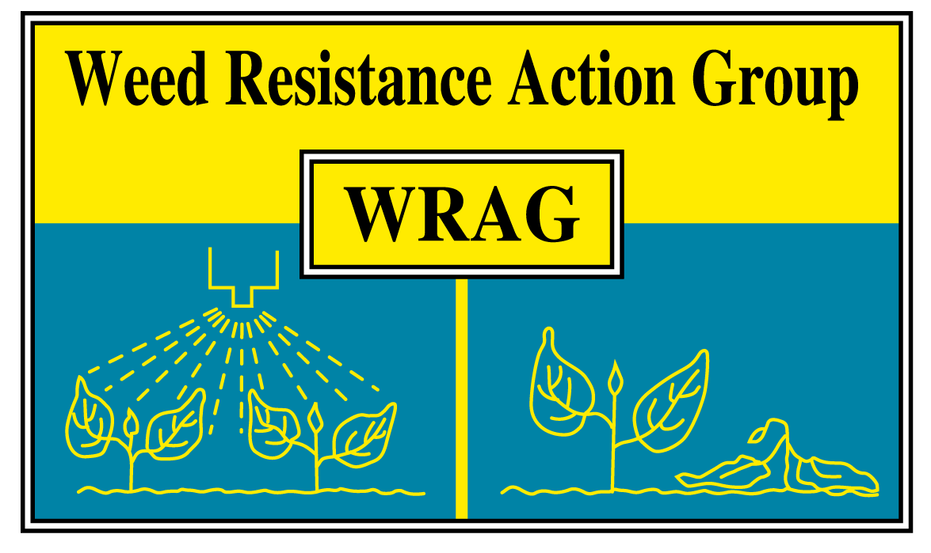

Thursday 17 March 2011, at Rothamsted Research

Members present (8): James Clarke (Chairman), Stephen Moss (Secretary), Francis Daly (CRD), Gordon Anderson-Taylor (Bayer), Steve Cranwell (DuPont), Anne Thompson (Dow), Jason Tatnell (Syngenta), Clare Bend (Masstock).

1. Apologies for absence. Paul Neve (University of Warwick); Mark Ballingall (SAC); Iain Ford (BASF),

2. The minutes of the last Steering Group meeting (18 March 2010) were approved.

These can be viewed on the WRAG website.

3. Review of impact of joint WRAG/RRA open meeting (18 March 2010) and revised Guidelines published in HGCA Managing Weeds in Arable Rotations Guide.

The meeting held in 2010 was well attended and feedback had been very positive. The revised resistance Guidelines were incorporated into the ‘Managing weeds in arable rotations – a guide’ booklet, published by HGCA for Cereals 2010. x copies of the guide were printed and have been widely distributed. A key aspect was the emphasis on non-chemical control methods and the importance of these at tackling resistant grass-weeds is certainly gaining greater recognition by farmers. It was felt that there was no immediate need for any new WRAG initiatives in relation to resistance Guidelines.

4. Resistance risk matrix – an output from the broad-leaved weed resistance project. Feedback since last steering group meeting.

WRAG Steering Group members had been asked to provide feedback on this after the last Steering Group Meeting, and some had done so. David Richardson, who has now left CRD, had been asked to discuss this at an EPPO meeting last year but it was unclear what progress had been made.

ACTION: Ingrid den Hoed to provide feedback on CRD’s current view on the use of the resistance risk matrix.

- Update on current status of herbicide resistance in UK.

Stephen Moss summarised the content of the paper ‘Current status of herbicide-resistant weeds in the United Kingdom’ presented at the AAB Crop Protection in Southern Britain Conference in Cambridge in February 2011. This provides the first comprehensive update since the last compilation exercise in 2005. A pdf of the full paper is attached to these minutes and Powerpoint versions of the maps are available from Stephen Moss. The following is a summary:

It is estimated that resistant Alopecurus myosuroides (black-grass) occurs on at least 80% of the 20,000 farms that spray regularly for control of this weed. Resistance to mesosulfuron+iodosulfuron, first used in the UK in autumn 2003, has been detected on >400 farms in 26 counties of England. Lolium multiflorum (Italian rye-grass) resistant to at least one herbicide mode of action has been found on >450 farms in 33 counties and resistant Avena spp. (wild-oats) on >250 farms in 28 counties of England. ALS-resistant Stellaria media (common chickweed) was found on >40 farms in 13 counties in England, Scotland and Northern Ireland. This represents the first documented case of a herbicide-resistant weed in Northern Ireland. ALS-resistant Papaver rhoeas (common poppy) was found on >25 farms in nine counties of England. ALS-resistance in Tripleurospermum inodorum (scentless mayweed) was documented for the first time in England, with resistant populations being found on three farms in Yorkshire. Partial resistance to the triazinone herbicides, metribuzin and metamitron, was also documented for the first time in England in Senecio vulgaris (groundsel), which also showed complete resistance to triazine herbicides.

- WRAG website. Changes needed and timescale.

It had been agreed at the last steering group meeting that the WRAG website needs updating and suggested changes to the structure had been circulated to all WRAG steering group members for further comment/additions. Francis Daly said that the CRD website was moving to a new server in the autumn, and this might result in changes to the style and format of web pages. Consequently, it would be better to wait until this change had occurred before modifying the WRAG website.

ACTION: Ingrid den Hoed/Francis Daly to notify Stephen Moss of progress in relation to CRD change of server, and then Stephen Moss to circulate suggested content revisions to all WRAG steering group members for further comment/additions prior to revamping the WRAG website.

7. Impact on resistance of restrictions on ALS sequences/mixtures for grass-weed control.

Jason Tatnell raised this and wondered whether these restrictions had impacted on the development of resistance. It was agreed that any effects are hard to quantify. CRD pointed out that such restrictions are not totally inflexible, and that there is the opportunity for companies to supply evidence in support of an application for the sequential use or mixtures of two ALS herbicide products. Such evidence would need to show that there was no substantial increase in resistance risk from such an approach. This would also apply to any application for increasing the dose of a product to help overcome resistance.

8. Provision of standard reference populations for resistance studies and concerns about reliability of seeds from some commercial suppliers.

Some concern had been raised about weed seeds supplied by commercial weed seed supply companies for use as reference populations in herbicide resistance tests. Most members were aware of such issues relating to seeds supplied to their company/organisation. In some cases these related to poor germination, but in other cases the resistance or susceptibility status of supplied seeds was not as described. Consequently, there was concern about the quality control aspects as the availability of reliable reference populations is essential in resistance diagnostic assays.

ACTION: James Clarke to contact commercial weed seed supply companies to enquire about quality control aspects in relation to supplies of herbicide resistant weed seeds.

- SOLAS – confidentiality issues in relation to resistance management.

Stephen Moss queried why the information on SOLAs did not include any details of the applicant. Previous contact with CRD indicated that this was viewed as confidential information. He queried why this should be, as it was likely that the applicant had information that was potentially useful to users. This was relevant to herbicide resistance in that promotion of more crop rotation and spring cropping has been highlighted as one means of non-chemical weed control. This might involve crops for which few herbicide were available. He used the example of grass-weed control in spring wheat as an example, where SOLAs for use of prosulfocarb and pendimethalin existed, but it seemed impossible to find any information on their likely efficacy on grass-weeds or crop safety. While accepting that applicants may have little or no efficacy or crop safety data, or not wish to share this information, it was also possible that the applicant did have such information and would be willing to share this. Some members of the committee were concerned about liability issues if the applicant’s name was supplied, although SOLA applications do make clear that use is entirely at users own risk. Most of the committee felt the existing SOLA arrangements worked well and that ‘rocking the boat’ was ill advised. Stephen Moss disagreed and felt that in these days of supposed ‘openess’, and ‘freedom of information’, there was no justification for keeping applicant’s details confidential.

- Recent resistance publications on reduced doses and resistance.

Professor J Gressel has recently published a paper claiming that low pesticide rates may increase the risk of resistance. (Low pesticide rates may hasten the evolution of resistance by increasing mutation frequencies, Pest Management Science). This issue was discussed but most of the committee agreed that reduced doses should be considered primarily from as an efficacy, rather than a resistance, issue. In the UK, the impact of reduced doses on reducing herbicide efficacy against grass-weeds was considered to be much more important, in practice, than any impact on resistance development. However, this is a contentious issue as some researchers, and members of WRAG, believe very strongly that lower doses do increase the risk of resistance. This may be a topic that needs revisiting.

- Resistance 2011 symposium and associated HRAC global meeting.

This symposium is being held at Rothamsted from 5 – 7 September and HRAC global are planning on holding a meeting during this period. The possibility of holding a joint meeting with HRAC global was raised, but the general view was that little would be achieved from such a meeting. It was agreed that this idea would not be pursued unless WRAG was approached by HRAC directly.

- Feedback from CRD.

Francis Daly said that David Richardson had now left CRD and his workload was being shared between other members of staff. In relation to the Sustainable Use Directive, consultation was ongoing with the 2nd stage in progress. There was a general view that much of what was required under this Directive was already being done in the UK, although further decisions would be needed by November 2011. He also indicated that additional active substances had been added to Annex 1, and these included cycloxydim and quinmerac. A meeting relating to buffer zones would be held soon too.

13. A.O.B.

An EPPO meeting is being held at Rothamsted in September, and EPPO (via Paul Ashby, CRD) would like to invite all chairs of the RAGs to attend a short meeting prior to the main EPPO meeting to discuss national issues.

Anne Thompson said that a meeting of the EWRS herbicide resistance working group is being held in Ghent, Belgium on 12/13 April. This is in the style of a symposium with many separate presentations on a wide range of herbicide resistance. Anne Thompson, Paul Neve and Stephen Moss are attending. The full programme can be seen at:

http://herbicideresistance.weebly.com/

Date of next Steering Group Meeting.

Thursday 15 March 2012 at ADAS Boxworth, starting at 10.30.

The committee thanked Rothamsted for providing facilities for this WRAG Steering Group Meeting.

Stephen Moss
WRAG Secretary Stephen.Moss@bbsrc.ac.uk 21 April 2011

H:\from m-drive oct98 then to h drive nov98\wrag\minutes\17March11\WRAG Minutes 17March11.docx

